Network Coursework Group Report
Introduction
The following document illustrates the design, implementation and equipment required for the installation of Lausen’s new IT infrastructure. It includes information that will be needed for the installation process as well as a cost specification for the equipment.

Assumptions made
- We can change the building layout (e.g. add/remove rooms)
- We only have to worry about the local LAN network and not the external internet connection.
- The company is probably going to want to expand by a minimum of double the current amount, e.g. 250 500 so we will take this into account when considering components.
- We can install cables in the ceiling/floors/walls etc.
- Our building measurements are correct as the building plans are hard to measure.
- The floor plans given appeared to be incorrect so we fixed them and assume that these are the correct plans.
- The building has the capability to handle the power consumption of the equipment.

Issues Influencing Design
During our feedback session for the logical design we had a few comments that needed to be addressed. The design was said to be a bit difficult to interpret as there are a lot of wires going to various different connections. To combat this we spaced the wires out in a way that makes them more readable, where we couldn’t do this (e.g. the server room) we colour coded the cables instead.

We wanted to use a star topology as this gives us lots of benefits in the network such as high speed, expandability, easily add/remove components etc. If one computer goes down it doesn’t affect the rest of the network, unlike other topologies such as a bus. In the feedback session for the logical design we realized that a star topology allowed too many points of failures. We wanted to minimize these as these could cause massive downtime for a large percentage of each workgroup. We then decided that a mesh topology would be more beneficial. This has made the design slightly more complex but has drastically reduced any points of failure. We wanted more switches for future expansion but didn’t want to leave them standing in a room not being used. Thus we decided to use them in the current implementation as extra fail safes to reduce points of failure. Having extra ports in all the switches as well also allows for an easy fix as if one switch goes down, as a group of PC’s can be re-wired to separate switches while the other switch is fixed or replaced. In places we have a lot of switches. The reason for this is that the workgroups should be considered as separate entities (as they could be separate businesses all together). Due to this, splitting workstations up becomes even more necessary e.g. if a workgroup of 50 loses 12 PC’s, connected to one switch, then that’s over 20% of their network down.
Building measurements
Ground floor
Length: 26m
Width: 9.1m (both sections)
Area: 236m²
1st floor
Length: 29.4m
Width: 9.1m
Area: 270.5m²

2nd floor
There are no measurements for this floor so we assume the measurements are the same as the 1st floor.
Based on cables used we have a limit of 100metres before the attenuation gets too bad for data transfer. We made sure to calculate the overall buildings measurements to prove that we can put Ethernet cables in the roof, floors and walls of the building without too much worry about length restrictions. With a length below 30m and a width below 10m for all three floors we can assume that any installation of over cables will not exceed 100m and therefore affect attenuation. This also takes into consideration twists and turns the cables may take.

Logical Design
Each section of the design represents each floor with the server room on the middle floor. Workgroups are split between 1 per server and there are different numbers of workstations per floor:
- 2nd floor 77
- 1st floor 96
- Ground 77

Workstations are grouped up as 6-8 per switch. This allows plenty of room for other PoE devices to be used in the ports e.g. security cameras, wifi gateways etc. Due to the nature of the mesh topology a user in a different workgroup can access their account from anywhere in the building. This makes overall maintenance easier as all computers use one system and then are split into workgroups. Of course each user will have their own username and password so this isn’t too much of a security concern.

Overview
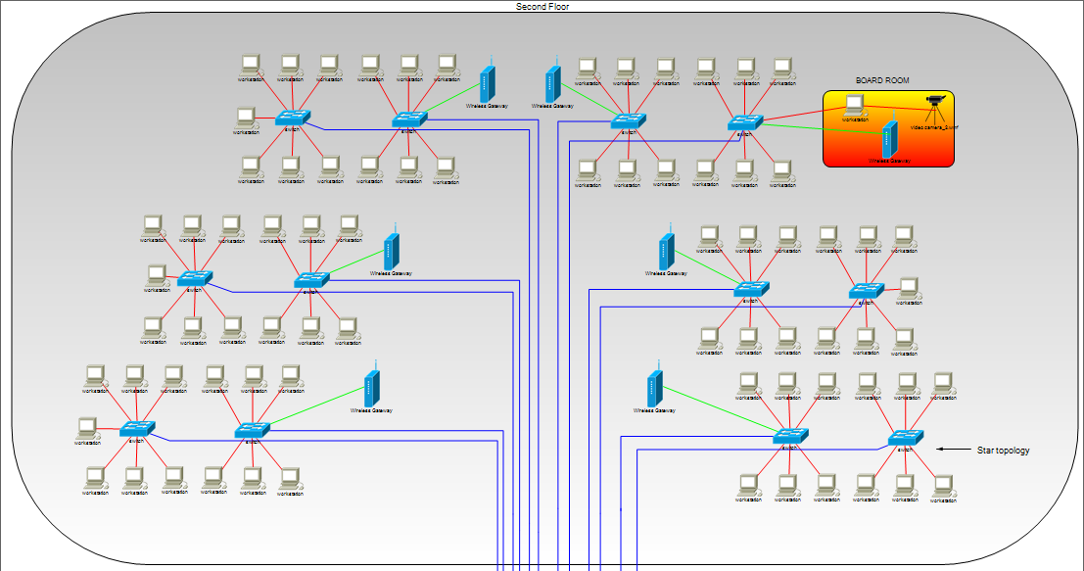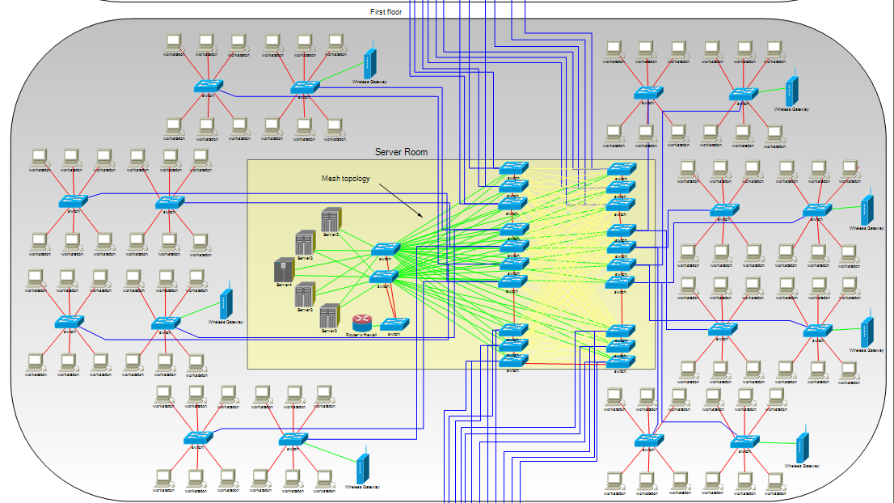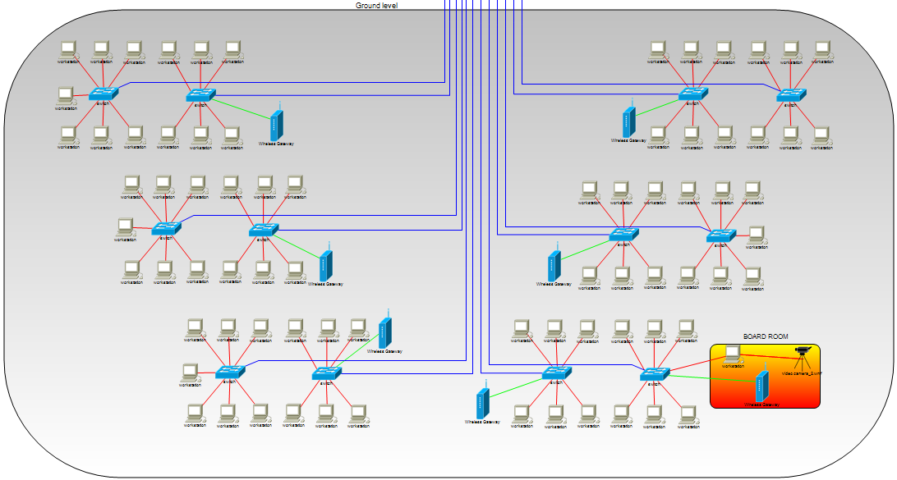
The full document can be found attached.

A few other things to mention are:
- In total we have 63 switches, which is a lot but as mentioned before, this comes with a variety of benefits.
- We also have seven wifi gateways per floor for mobile access.
- We have the boardrooms showing the equipment for them.
- We have a router for external internet access.
- The lines for cables are in different colours, due to readability, but all cables are 10GbaseT.
Throughput
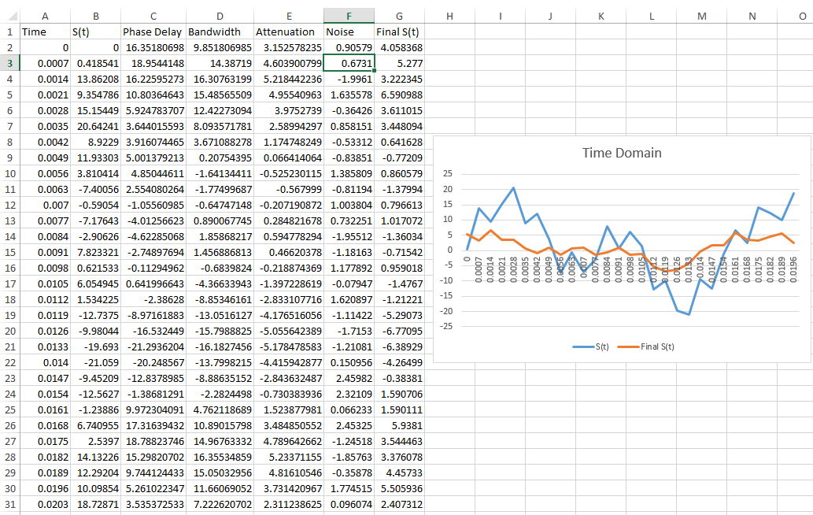
For the throughput of our cables we used the above data to produce a graph of the final speeds whilst taking into account phase delay, bandwidth, attenuation and noise. First we decided the time segment to use, every 0.0007s which gives us sensible range that gives us a variety of comparable results. For s(t) we used the following formula:

From here the phase delay is worked out in a similar way. We then add the phase delay to each component which means we divide each section by 8, 4 and 2 respectively e.g.

After this we take into account the bandwidth which is the same as before except that we remove any values out of the range of the wires frequency (250MHz for cat6). So here we remove the last value to get:

For the attenuation we took the data based on of Siemon’s, “What Really Changes with Category 6“ (2015, para 13) tests that gave an attenuation of 0.32 when at a frequency of 250MHz so for the next column we took this value and multiplied it by the bandwidth, this gives attenuation for each different bandwidth value.

The next part was to work out the noise. We used the RAND function in excel for this. It generates a random number between -2.5 and 2.5. The formula is as follows:
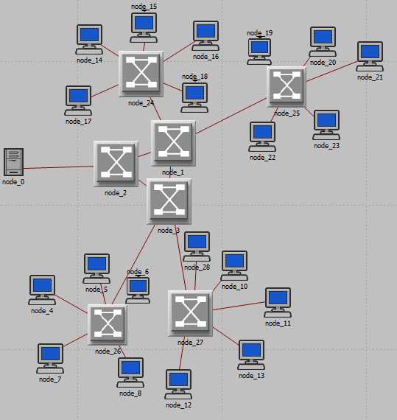
=RAND()*(2.5-(-2.5))+(-2.5)

Simulations
Note that due to limitations of the simulation software we have simplified the network down to what it would be like with just 1 server. The results of which can be seen below and the layout for the simplified network is on the right.

Delay
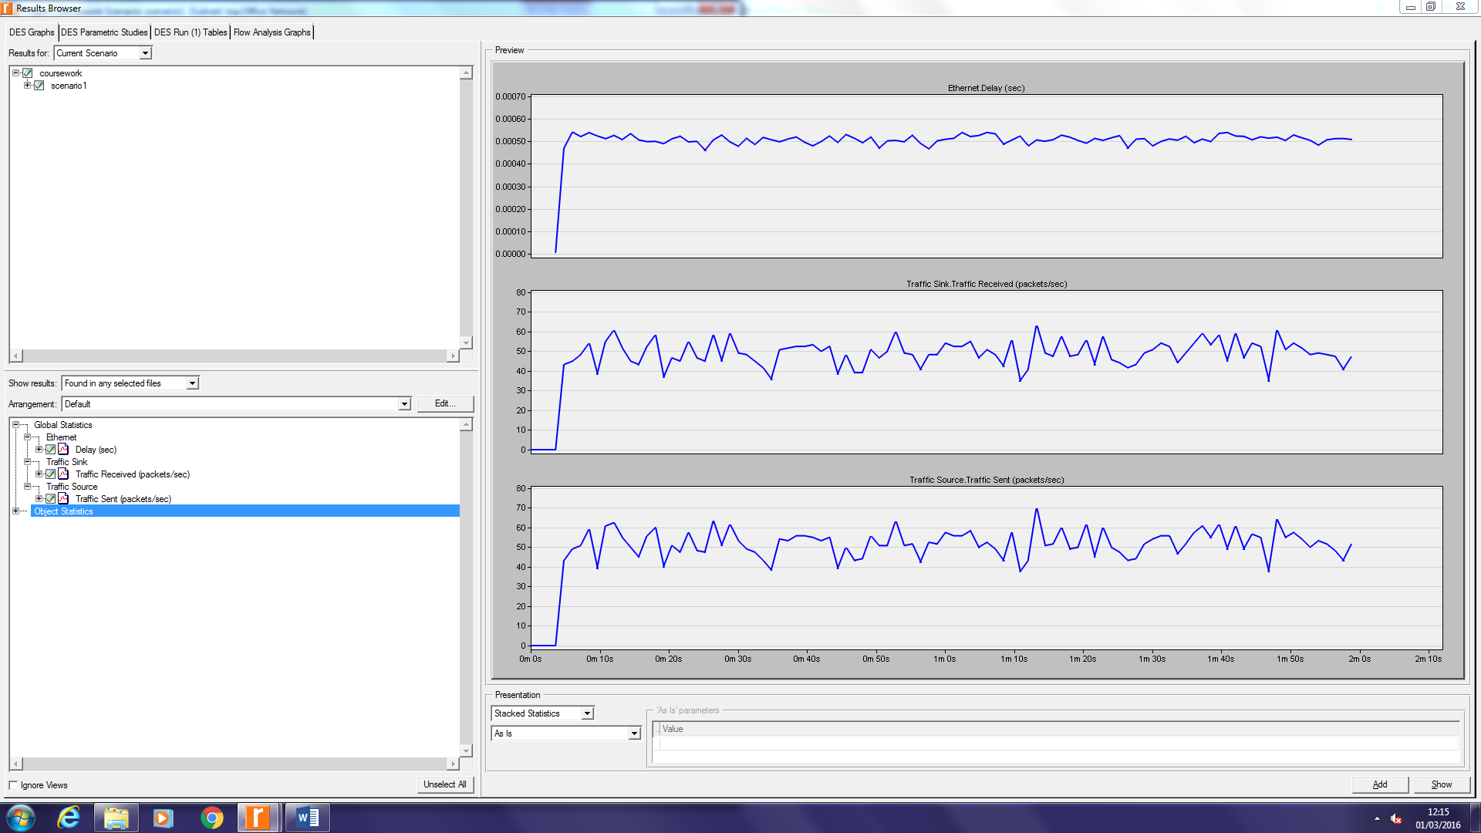
Traffic Sent

Traffic Received

As we can see from the results from the simulations show that the network should work fine, even if we multiply the values by the number of other components in the system it should still be able to manage the data load. The traffic sent and received have very few differences which is great and the delay seems very stable which is also really good, however, things may be different during the physical implementation.

Physical Design
When designing the physical design we needed to work out where to place the equipment. The 5 servers, router and the majority of switches will be kept in a central room on floor 2. There will also be two rooms, one on the 2nd floor and one on the ground where the cables will pass through. These already exist, however, the server room doesn’t. This server room will have to be built in the middle of the second floor. We decided against having server rooms for each floor as this would increase the cost of air conditioning units as well as being problematic with the placement of the servers, e.g. dampness, heat etc. After some research on optimal server location we discovered that it would be best to place the server room on a central floor as well as away from any external walls, this is to reduce the chances of moisture and heat getting in the server room and therefore damaging the components according to Sun Microsystems, “Sun Microsystems Data Center Site Planning Guide” (2002, para 12). In each room the computers will be laid out in a manner that allows cabling to go through to the roof from a central pole.

We used different colours for the cables in the physical design to help with readability, this is easier to see where they connect to. These don’t have to be implemented in the actual system but we think it would be best to do so for future maintenance. Each cable should be labelled as well showing which port it is going to and coming from. This could save hours of work down the line when having to remove and add cables.

Ground floor layout
1 Computer
Projector
6 Computers
Cables
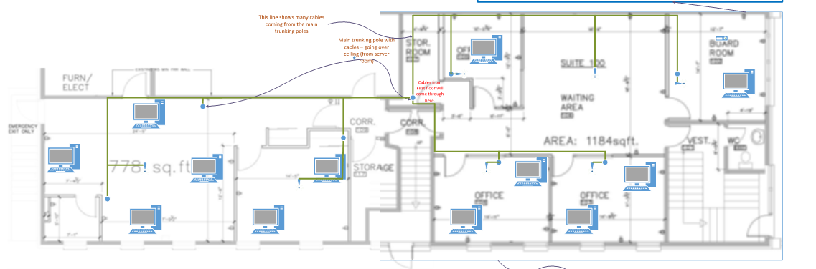
Trunking pole
1 Computer symbol = Group of 6 computers organized
by 1 switch, except in the board rooms where it is only 1.
Group of workstations
Wifi gateway

Boardroom layout
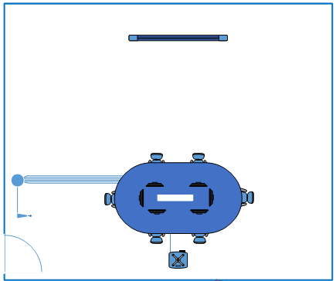
Workstation
Cables
Trunking pole
Wifi gateway
Projector and smartboard equipment

Offices layout
Trunking pole
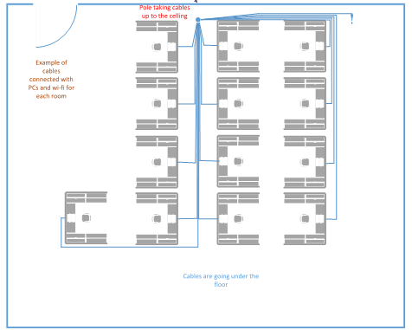
Cables
Wifi gateway
Workstation

Server room layout (see attached document)
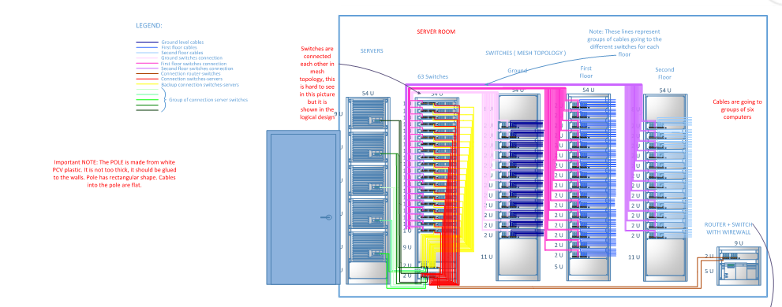

1st floor layout
Server room
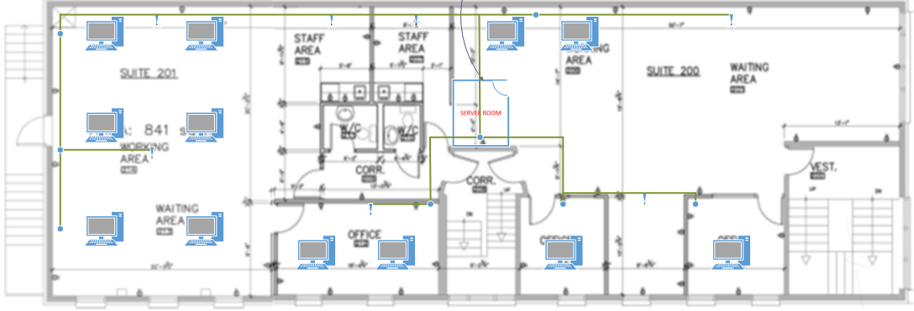

1st floor working area layout
Workstation
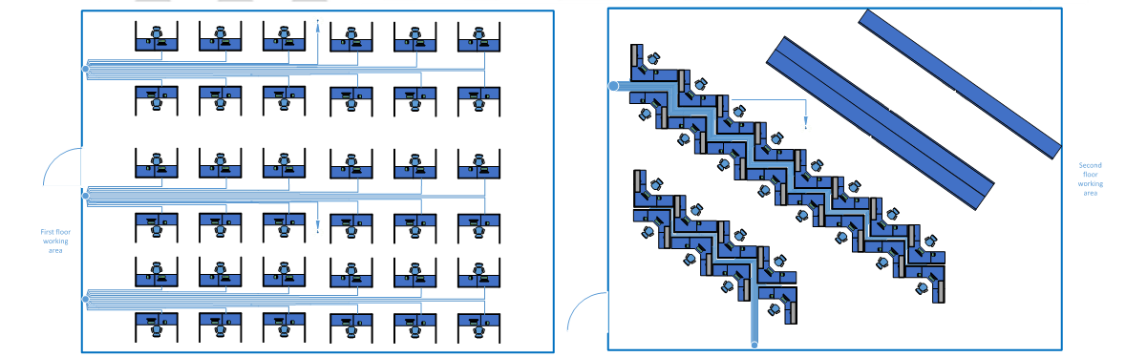
2nd floor layout
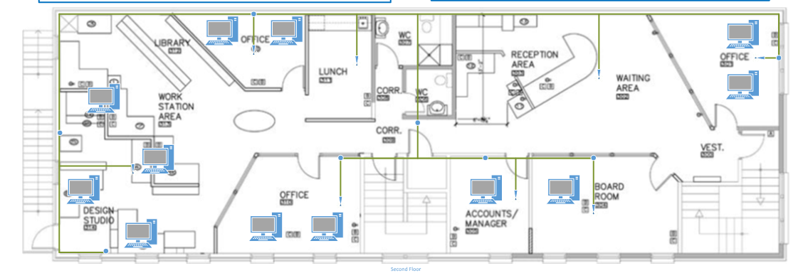
1 PC
2nd floor working area layout
Workstation
Full document can be found attached.

Component and Costs Specification

Our switch contains 28 ports that support 10/100/1000 Gigabit Ethernet. The amount of ports is enough that it covers all our needs for switches in the network as well as allowing for future expansion such as PoE devices, wifi access points, and more computers. For the wireless access points we decided to go for high quality business grade to make sure that the connection is fast, stable and that runs dual band frequencies. For the Ethernet cable we decided to go for CAT6 so as to support up to 1000BASE-T allowing for re-use of cables if the network expands its other devices. We also want shielded twisted pair cables so that the networks data is protected during transmission. For an external router we chose the RV180 VPN Router by CISCO which should handle all the external traffic for the network. Most of the information will be internal so this doesn’t need to be as powerful and we are assuming that the company will sort out their own external connections anyway so will replace or add more routers if they need to. We need to make a new room for servers. The size of the room we want to make is the same as the staff area to left as seen in the logical design. In the server room we have quite a lot of devices and these can build up heat. We therefore need to keep the server room cool. To counter this we decided that 3 M-Series AC MSZ-HJ25VA coolers from Mitsubishi would more than handle the cooling problem. We hope to have 2 on all the time and have 1 as a backup in case one of the others fails.

Cabling and New Room Cost Calculations

If we use the length of the building and the number of workstations as an estimate we get 29.1m x 250, which gives us 7275 cables. As both the length and the width of the building measurements are below 30m we can assume that a third of the amount of cabling will still be enough with plenty left over, so 2425 x 100m should be more than enough.

Based on the floor plans the room size is 0.63ft², multiply this by an average cost of $124 (£89.38) per square feet, based on FIXR, “How much does it cost to add a new space?” (n.d., para 3) we get $80.64 (£58.13) for the installation fee but as a rough estimate materials should be about £1000.

Full Cost Specification

Component | Type | Quantity | Price | Total Price | Source
Cisco SG300-28P | Switch | 63 | £399.99 | £25,199.37 | Amazon, “Cisco SG 300-28P 28-port Gigabit PoE Managed Switch” (n.d.)
Linksys LAPAC1200 | Wireless Access Point | 21 | £137.98 | £2897.58 | Amazon, “Linksys LAPAC1200 Business Access Point Dual Band AC1200 2 x 2” (n.d.)
CAT6 Ethernet 1000BASE-T | Cable | ~2425 x 100metres (see above calculations) | £7.35 per 50m | £35,647.5  (see above calculations) | FreeTV, “50m CAT6 Ethernet Network Cable Roll” (n.d.)
RV180 VPN Router by CISCO | Router | 1 | £353.97 | £353.97 | Amazon, “NET Small Business RV180 VPN Router” (n.d.)
Open Frame Server Racks 50U | Device Racks | 5 | £330 | £1,650 | Rack Solutions, “Open Frame Server Racks” (2016, para 8-15)
Open Frame Wall Mount Rack 16U | Device Racks | 1 | £133.49 | £133.49 | Rack Solutions, “Open Frame Wall Mount Rack” (2016, para 7-13)
Server Room | New Room | 0.63ft² | £89.38 per 1ft² + £1000 for materials (see reference and above calculations) | £1058.13 | FIXR, “How much does it cost to add a new space?” (n.d., para 3)
M-Series AC MSZ-HJ25VA by Mitsubishi | A/C | 3 | £505 | £1515 | Orionair, “Mitsubishi Electric Air Conditioning MSZ-HJ25VA Wall Mounted” (n.d.)
SMART Board Interactive Whiteboard 680 | Board room equipment | 2 | £325.00 | £650.00 | Amazon, “SMART Board Interactive Whiteboard 680 - touch-screen, stylus” (n.d.)
SMART TECH UX60 PROJECTOR | Board room equipment | 2 | £600.00 | £1200.00 | Amazon, “SMART TECH UX60 PROJECTOR” (n.d.)
Cable Trunking 60x30mm - 1.5m length | Trunking pole | 24 | £16.99 | £407.76 | Amazon, “Cable Trunking 60x30mm - 1.5m length” (n.d.)
Total | - | - | - | £70,712.8 | -

References

Amazon (n.d.). Cisco SG 300-28P 28-port Gigabit PoE Managed Switch. Retrieved from
http://www.amazon.co.uk/Cisco-300-28P-28-port-Gigabit-Managed/dp/B0042RQIOO

Amazon (n.d.). Cable Trunking 60x30mm - 1.5m length. Retrieved from
http://www.amazon.co.uk/Cable-Trunking-60x30mm-1-5m-length/dp/B001DNAOEA

Amazon (n.d.). Linksys LAPAC1200 Business Access Point Dual Band AC1200 2 x 2. Retrieved from http://www.amazon.co.uk/Linksys-LAPAC1200-Business-Access-AC1200/dp/B00KDG53T4

Amazon (n.d.). SMART Board Interactive Whiteboard 680 - touch-screen, stylus. Retrieved from
http://www.amazon.co.uk/SMART-Board-Interactive-Whiteboard-680/dp/B0076Z5MP0

Amazon (n.d.). SMART TECH UX60 PROJECTOR. Retrieved from http://www.amazon.co.uk/SMART-Technologies-UX60-TECH-PROJECTOR/dp/B01AGXP7YO/ref=sr_1_2?s=electronics&ie=UTF8&qid=1456602735&sr=1-2&keywords=smart+board+projector

Amazon (n.d.). NET Small Business RV180 VPN Router. Retrieved from http://www.amazon.co.uk/NET-Small-Business-RV180-Router/dp/B007RLFM7G

FIXR (n.d.). How much does it cost to add a new space?. Retrieved from
http://www.fixr.com/costs/add-new-space

FreeTV (n.d.). 50m CAT6 Ethernet Network Cable Roll. Retrieved from http://www.freetv.ie/50m-cat6-cable.html

Orionair (n.d.). Mitsubishi Electric Air Conditioning MSZ-HJ25VA Wall Mounted. Retrieved from
http://www.orionairsales.co.uk/mitsubishi-electric-air-conditioning-msz-hj25va-wall-mounted-25kw--9000btu-inverter-heat-pump-240v50hz-2166-p.asp

Rack Solutions (n.d.). Open Frame Server Racks P/N: Rack Model 111. Retrieved from https://www.racksolutions.co.uk/server-racks-cabinets-enclosures.html

Rack Solutions (n.d.). Open Frame Wall Mount Rack. Retrieved from https://www.racksolutions.co.uk/wall-mount-rack.html

Siemon (2015). What Really Changes with Category 6. Retrieved from https://www.siemon.com/uk/white_papers/04-01-15_cat6.asp

Sun Microsystems (2002). Sun Microsystems Data Center Site Planning Guide. Retrieved from http://docs.oracle.com/cd/E19065-01/servers.e20k/805-5863-13/ch1.html#pgfId-13059

